Techniques for Developing Computer Systems Questions

- A major software project is being developed by a project manager using SSADM.
(a) Give four advantages of using SSADM in designing the new system.

[4]
(b) Describe two software tools that can assist the work of the project manager.

[6]
- A systems analyst is employed to produce a new computer system for a large business.
The analyst is able to use a number of software tools to help in the work.
One software tool allows for the production of Gantt charts.
(a) Describe the features of a software tool to produce Gantt charts.

[4]
(b) Identify and describe the features of one other software tool that can be used during the development of a new system.

[4]
Continued on the next page.
- A complex problem is to be solved. The analyst has split the problem up into a number of different tasks to be carried out.

A represents the collection of information about the problem.
B represents the analysis of the information.
C represents the design of the solution.
D represents the creation of data files.
E represents the writing of the software.
F represents the testing of the solution.
G represents the creation of the documentation.
H represents the installation of the finished project.

(The units used on the chart are days.)

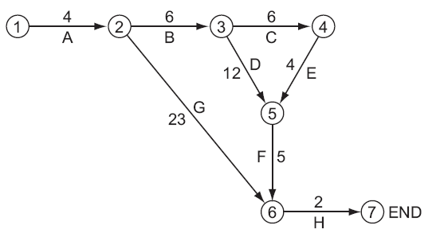

The Program Evaluation and Review Technique chart (PERT) has been drawn to allow critical path analysis of the problem.

(a) Explain what the chart shows about the relationships between the various tasks.

[6]
(b) State the critical path.

[1]
(c) State the least time required to complete the project.

[1]
- Discuss the need for project management when a major project is being implemented.

