Entity-Relationship (E-R) Diagrams Mark Scheme

4 marks for entities
6 marks for relationships
4 for relationship descriptions
(1 per point, max 10)
(10)

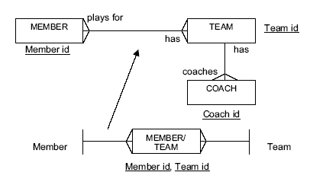
Mark points:
1 per correct entity max 3
1 per relation max 2
1 per statement max 4
1 for attempt at link entity
1 for sensible name (mix of both)
2 for correct relationships
1 for id keys
1 for link key
(max 13)
(13)
- (a)
Mark points:
1 for each of original tables, max 3
1 for a link table
2 for an example of a two-way relationship shown
1 for each correct link, max 4
(10)
(b) - Eucalyptus AND
- Batch 12
- found in PLANTS table
- Individual gardens found in Design/Plants table
- Customer for those gardens are found (via account in Accounts table)
(1 per -, max 4)
(4)
STUDENT
FORM
TUTOR
TEACHERS
(6)
- A diagrammatic means of showing a
-database.
-The things that are represented in the database are shown
-along with the relationships between them.
-Included in the representation are the attributes of each entity, or the information stored about each entity.
Notes: This is often referred to as a data model rather than an entity model.

