Object Orientated Programming Paradigm (OOP)

- In a particular object oriented programming language, the following classes are defined.
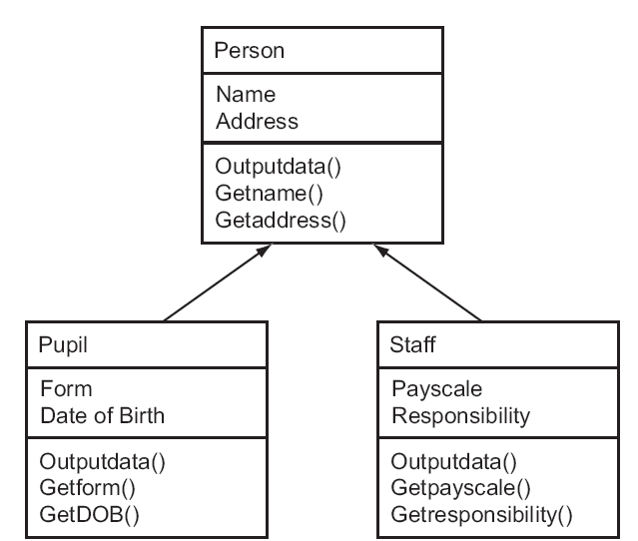

With reference to the diagram explain the terms:
(a) Data encapsulation

(b) Inheritance

[4]
- Explain the term instantiation.

[2]
- Describe the following programming paradigms
Object-oriented,

[2]
- Describe three characteristics of an object-orientated approach to problem solving.

[6]

