Reverse Polish Notation (RPN) Mark Scheme

- (a)
-Removes ambiguity from algebraic expressions
-No brackets required
-Allows for processing using stacks
(1 per -, max 2)
[2]
(b)
(a+b)/(c-d)
(1 for each bracket and 1 for / sign)
[3]
(c)
a2bc+*/
(1 for bc+, 1 for bc+ within 2 *, 1 for 2bc+* within a /)
[3]
2.
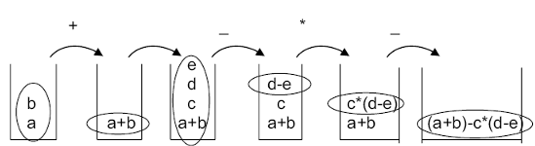
Mark points:
-at least two operators shown between transitions
-a and b in first stage
-a+b after first operator
-e,d,c, (a+b) in stack in correct order
-(d-e)
-c*(d-e)
-(a+b)-c*(d-e)
(1 per -, max 6)
[6]

