Algorithms - Trees Mark Scheme

- (a) Feddi

Eda Joh

Dav Gali Sean

Marks:

-Root node
-Eda and Joh correctly positioned in relation to Feddi
-Eda’s subtree
-Joh’s subtree
(4)
(b) - compare with root
- if < go to left sub-tree
- else go to right sub-tree
- repeat until no sub-tree
- insert at node
Accept mirror image if used in (a)
(max 4)
(4)
(c) -Data in a tree serves two purposes (one is to be the data itself) the other is to
act as a reference for the creation of the subtree below it
-If Joh is deleted there is no way of knowing which direction to take at that node to find the details of the data beneath it.
-Solution 1 is to store Joh’s subtree in temporary storage and then rewrite it to the tree after Joh is deleted. (The effect is that one member of the subtree will take over from Joh as the root of that subtree).
-The data, Joh, can be marked as deleted so that the data no longer exists but it can maintain its action as an index for that part of the tree so that the subtree can be correctly negotiated.
(4)

Notes: The tree can be reflected in a vertical mirror quite justifiably. For this reason it is probably worthwhile making a note on the diagram of what rule has been used, just in case it does not match the examiner’s version.
Total = 7 marks
- (a)
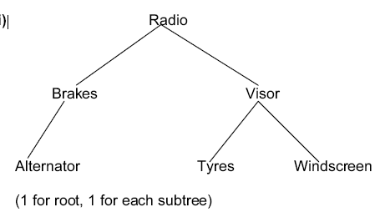
(b) -Read root
-Compare with clutch
-Clutch<Radio therefore traverse left subtree
-Read root (Brakes)
-Compare with Clutch
-Clutch>brakes, therefore traverse right subtree
-Root empty
-Insert Clutch
(1 per -, max 5. Completed tree worth 3)
[5]
(c) -Traverse left subtree
-Read/output the root
-Traverse right subtree
Route shown clearly on diagram is acceptable
-Route
-Indication of when nodes are read
-Description of diagrammatic representation
[3]
- (a) Ash, Jam, Lie, Poa, Ros, Siv
(1 mark for starting with Ash, one mark for the remainder correct)
[2]
(b) Poa, Jam, Ash, Lie, Siv, Ros
(1 mark for starting with Poa, one mark for the remainder correct)
[2]

- (a)
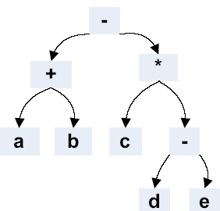
Mark as follows...
-sign at the root
-Correct left subtree
-Correct right subtree
1 mark for each –
(b)
a b + c d e - * -
Mark as follows...
- a b + (at the start of the expression)
- c d e - *
- Minus sign at the RHS of expression
(1 per •, max 6)
[6]

